**Assignment No. : 14** Date : 02.01.2023

**Problem Statement :**

A program to read two images ‘lena.bin’ and peppers.bin’. define a new 256 x 256 image J as follows : the left half of J i.e., the first 128 columns, should be equal to the left half of lena image and the right half of J, i.e., the 129th column through the 256th column should be equal to the right half of pepper image. Show J image.

**Algorithm :**

**Variables Listing :**

img1, img2 = stores the image

**Steps :**

Step 1 : Import the OpenCV library using the module cv2.

Step 2 : Import numpy as np.

Step 3 : Read the images data using imread() and store it in img1 and img2.

Step 4 : Resize them to 256x256.

Step 5 : Create a horizontal stack with 0 to 127 pixels of one image and 128 to 256 of the other.

Step 6 : Display the stack.

* **Source Code :**

import cv2

import numpy as np

img1=cv2.imread('Lenna.png')

img2=cv2.imread('arceus.jpg')

img1=cv2.resize(img1,(256,256))

img2=cv2.resize(img2,(256,256))

img3=np.hstack((img2[:,0:127],img1[:,128:256]))

cv2.imwrite('Combined2.jpg',img3)

* **Input and Output :**

Set 1 :

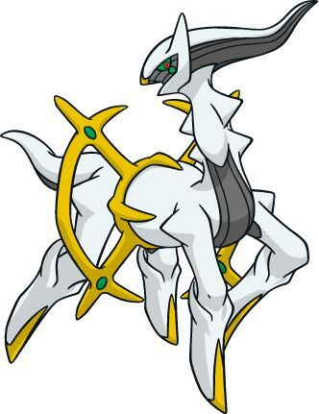Input :

Output :

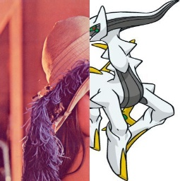

Set 2 :

Input :



Output :

